January 2023
Serious Violence in
West Lancashire
District Needs Assessment

Lancashire Violence Reduction Network
Teigan Whiffing (VRN Intelligence Analyst)

Executive Summary

The following needs assessment is one of 14 produced for each of the 14 districts within the Lancashire area. These needs assessments intend to provide an overview of the area in terms of risk and protective factors for violence to support areas in addressing this need with appropriate action, reflecting the aims and objectives of the violence reduction network.

Aims and Background
This needs assessment seeks to provide an understanding to the Violence Reduction Network (VRN), partners and public about the reality of violence within each district of Lancashire, and the prevalence of the underlying risk factors of violence. This assessment is a reflection of the Pan-Lancashire ‘Strategic Needs Assessment’ for specifically West Lancashire.

A Public Health Approach to Serious Violence
A growing body of evidence tells us that violence is preventable. Since the publication of the World Health Organization’s World report on violence and health in 2002, experience, research and intelligence has generated an understanding of the risk factors that contribute to violence, and the many things that can be done to prevent it. We have a growing body of knowledge regarding the impact of violence and those most at risk of being either a perpetrator and/or victim. This understanding allows us to design and implement a public health approach to violence prevention around evidence-based frameworks.

The preventable nature of violence naturally lends itself to a public health approach. Violence reflects many of the other common facets of important public health issues. There are wide inequalities in the prevalence of violence, with the greatest impacts being felt by the most deprived communities (Protecting People, Promoting Health, 2021). There is also a cyclic nature of violence. For example, there is sound understanding that exposure to violence in childhood (amongst other adverse childhood experiences), increases the likelihood of an individual becoming involved in violence later in life. Finally, there are masses of data sources from across a range of partners, which support the implementation of life-course prevention strategies at a universal through to a targeted level.

Approach
This needs assessment includes the following areas of information:

- A demographic overview of the district;
- Epidemiology* of risk and protective factors for violence in the district;
- A violent crime problem profile for the district.

*Epidemiology is a quantitative public health discipline which looks at the frequency and patterns of events in a group of people and what the risk and protective factors are.

Table of Contents

Executive Summary 3
Aims and background 3
Public health approach to serious violence 3
Approach 3
Serious Violence Definition 5
Data Sources 5
Demographic of West Lancashire 6
Population 6
Age and Sex Structure 6
Housing 7
Risk and Protective Factors for Serious Violence 7
Education 7
Employment and Income 8
Health and Wellbeing 8
Violent Crime Profile 9
Serious Violence 9
Perpetrators and Offending 10
Health Demand of Violence 10
Cost of Violence 11

Serious Violence Definition

‘Violence is the intentional use of physical force or power, threatened or actual, against oneself, another person, or against a group or community that either results in or has a high likelihood of resulting in injury, death, psychological harm, maldevelopment, or deprivation.’

(World Health Organization)

At the inaugural meeting of the Lancashire Violence Reduction Network leadership board, data was presented to contextualise the local picture and the definition of serious violence was agreed. These crime types and descriptors are:

Assault resulting in injury

Rape

Robbery

Aggravated Burglary

Domestic Abuse and Violence
(DAV)

Child Exploitation (Sexual and Criminal)

Homicide

Knife Crime

Gun Crime

Using this definition means there are some crimes which will appear in multiple groups as not all crime categories are independent crime classifications. For example, an assault resulting in injury between two domestically related persons using a knife will be considered in three categories: knife crime, assault with injury and domestic abuse and violence.

Data Sources

Data included in this needs assessment has been taken from several sources:

- Public Health England (PHE) fingertips
- Lancashire Insight
- Office for National Statistics (ONS)
- GOV.uk: Home Office statistics

Note – whilst there is more data available than that included in this needs assessment, only those updated since 2020/21 have been included to ensure relevancy (several from an earlier period are included, where relevant). A previous version was produced in 2021 and should be referred to for additional data prior to 2021 (please contact the VRN for this previous version).

All of the data used and discussed within this needs assessment is public-access, population level data. For this reason, this needs assessment can be distributed and shared with those necessary with reference to the original data sources as outlined prior. Any data caveats or data quality issues are listed within the original data sources and should be reviewed before any interpretations are made of the findings.

Demographic of West Lancashire
West Lancashire is an authority area in South Lancashire (policed by South division of Lancashire Constabulary) that covers 347 square kilometres. West Lancashire is made up of 25 wards (at the time of the 2011 Census).

Population
West Lancashire had a higher than national average rate of deliveries to teenage mothers (12–17-year-olds) at 1.1% compared to 0.7% (2020/21). However, West Lancashire had slightly less babies (6.3%) born at a lower birth weight compared to 6.8% nationally (2020).

The population of West Lancashire (‘mid-year estimate’, Census 2021) was 117,400. This was the 6th highest recorded of the 14 districts in Lancashire.
The population of West Lancashire is estimated to increase by 3.8% between 2018 and 2043. This is the 3rd lowest rate for all 14 districts.
West Lancashire had an estimated population density (number of people per km²) of 339. This was the 3rd lowest across the 14 districts.

Age and Sex Structure
West Lancashire has a near equal split of sex within the district, with a 51.6% female population, and a 48.4% male population. For both females and males, the highest recorded age band was 55- to 59-year-olds.
65+
20-64
56%
24%
56%
22%
24%
21%
Male
Female
0-19

Housing
£210,000 median house price (£285,000 England average)
2.3 homeless households per 1,000 (3rd lowest in Lancs)
1,302 vacant dwellings (5th lowest in Lancashire)
51,230 dwelling stock (7th highest in Lancashire)
15 households in temporary housing (7th lowest in Lancs)
29% of housing in council tax band A (40% in the North West)

Risk and Protective Factors for Serious Violence

Education
1.7%
of young people (known to local authority) in West Lancashire were NEET (not in education, employment or training) during 2020/21. This is lower than the North West total rate (3.4%), and the England total rate (2.8%).

In the year 2020/21, West Lancashire made 12 permanent exclusions – this equates to a rate of 0.08 (6th lowest in Lancashire). There were also 506 suspensions – this was a rate of 3.2 (4th lowest in Lancashire).
The average attainment 8 score (measure across 8 core qualifications scored at the end of key stage 4 for state-funded school pupils) in West Lancashire is 49.6, this is the same as the North West average score of 49.6 (2020/21).

Employment and Income

West Lancashire has a below North West rate (73.2%) of the working age population in employment at 71.3%. This is the 4th lowest employment rate across the Lancashire districts.
West Lancashire has the 5th lowest rate of persons on universal credit (12.8%). This was also lower than the North West rate of 15.9%.

West Lancashire has 15.7% of under 16’s living in ‘relative’ low-income families (6th lowest in Lancashire), this is below the North West rate of 21.2%. Similarly, West Lancashire has 11.8% of under 16’s living in ‘absolute’ low-income families (6th lowest in Lancashire), which is also lower than the North West rate of 16.6% (2020/21)

Health and Wellbeing
The life expectancy of males born in West Lancashire is 77.1 – this is between the North West life expectancy of 77 and 78.7 in England. Similarly, the life expectancy of females born in West Lancashire is 82.8 – this is above the North West life expectancy of 81 and 82.6 in England (2020).
Below North West rate (500) for admission episodes for alcohol-related conditions at 386 per 100,000 (2020/21)

Above the North West rate (64.5%) for physically active adults at 65% (2020/21)

Above the North West rate (11.0%) for smoking status at time of delivery at 12.5% (2020/21)

Above the North West rate (11.4) of suicide at 12.4 per 100,000 (2020)

Violent Crime Profile

Serious Violence
Whilst the focus of the LVRN is on the underlying drivers of serious violence as depicted prior, it is also important to understand where serious violence is taking place within a locality. When referring to serious violence here, this is reflective of the Home Office Crime types – violence against the person, and sexual offences as opposed to the LVRN serious violence definition.
As you can see in the right-hand side graph, the annual volume of serious violence has been increasing in West Lancashire, to over 2,000 recorded crimes in 2021/22. In addition, the left-hand side image shows West Lancashire separated by lower super output areas (LSOAs). From this heat map, you can see the LSOA that has the highest volume of serious violence is 014A (Skelmersdale South East).

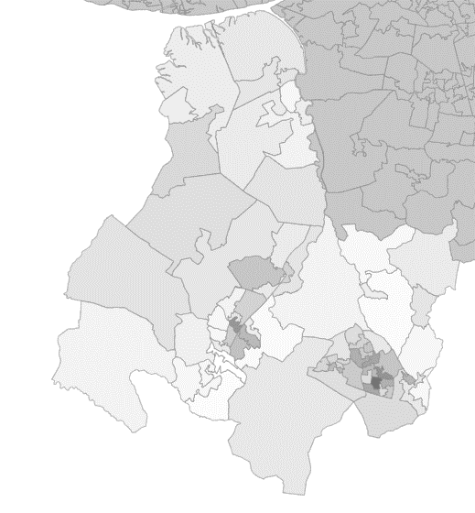

West Lancashire had the lowest rate (11.3 per 1,000) for hate crime (2021/22).
The most common motivation for hate crime being race/ ethnicity/ nationality

In 2021/22 West Lancashire had the 4th lowest volume of serious violence in Lancashire, with a rate of 21.6 violent offences per 1,000 population compared to 29.5 nationally, and 34.5 regionally (2020/21)

Between 2021/22 Digmoor Ward had the highest number of domestic abuse incidents in West Lancashire at 22.6 per 100,000 (27th highest ward in Lancashire), followed by Moorside Ward (17.9), and Tanhouse Ward (17.6)

Perpetrators and Offending
West Lancashire had the 3rd lowest volume of juvenile reoffenders (2019/20). These were most commonly White males, aged 15 to 17.

West Lancashire had the 3rd lowest volume of adult reoffenders (2019/20). These were most commonly White males, aged 25 to 29.

Male and female offenders of violence were most commonly aged 15 to 19. Whilst male and female victims were most commonly aged 30-34.

See ‘Lancashire Strategic Assessment’ (Partnership Intelligence, 2022-2025) for further detail on the long-term issues and threats from crime and antisocial behaviour across Lancashire (by district area).

Health Demand of Violence
The below outlines the standardised rate (per 100,000) of hospital admissions for violence (including sexual violence) during the years 2020/21. As you can see, the rate for West Lancashire was between the North West and England rate.
59.0
41.9
61.6
West Lancashire

North West
England

Halsall Ward had the highest number of ambulance call outs at 149.7 per 1,000 population (64th highest ward in Lancashire), followed by Birch Green Ward (147.7), and Wrightington Ward (144.4).

West Lancashire also has a below average rate of emergency hospital admissions for intentional self-harm. During 2020/21, the rate per 100,000 population was 214.1, compared to 225 in the North West, and 181.2 in England.

See ‘Demonstrating the Costs of Violence to the Healthcare System: Development of a costing tool’ (Liverpool John Moores University, Lisa Jones, 2021) for further detail on the financial demand that violence places on the healthcare system within Lancashire.
Cost of Violence
To calculate the cost of serious violence within Lancashire, the ‘Home Office Economic and Social Cost Estimates’ were used, multiplying the recorded crime (robbery, homicide, rape and violence with injury) in that district between June 2021 and July 2022, by the estimate unit cost. The below infographic shows these costs per district to the nearest million.
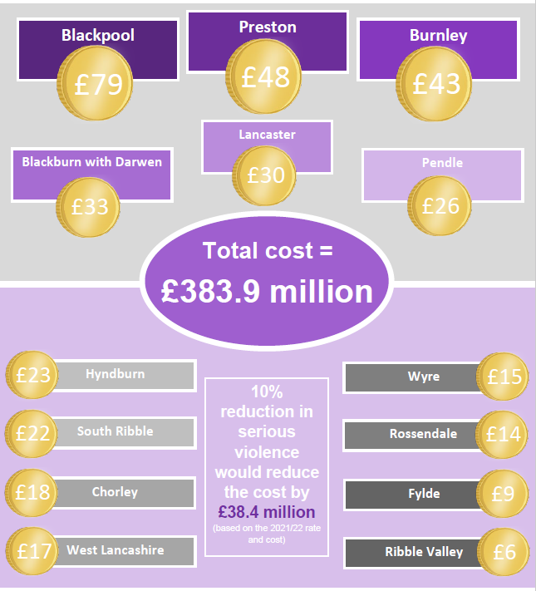
As shown, serious violence in West Lancashire was estimated to cost approximately £17 million between 2021 and 2022, making it the 5th lowest costing district in Lancashire.

+44 (0)1772 537 026
@LancsVRN
LancsVRN.co.uk
LancsVRN@lancashire.pnn.police.uk
Lancashire Violence Reduction Network
County Hall, Preston, PR1 8XB

